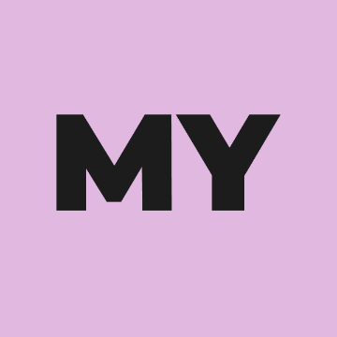
Yoga Alliance Professionals & British Wheel of Yoga
Menopause Yoga & Wellbeing
Teacher Training Module
Petra Coveney

Pre Course Information Form for courses run in conjunction with Yogacampus

Name:

Your BWY and / or Yoga Alliance Professionals Membership No (if you are a member of either organisation):

Date of Birth:

Address:

Contact Telephone:

Email address:

Website:

Please confirm you are in a stage of menopause.

Where did you complete your Yoga Teacher Training? How many years have you been teaching yoga and what style?

Why would you like to learn about Menopause Yoga & Wellbeing? Please summarise your reasons in around 200 words.

Do you have any relevant qualifications in other areas of wellbeing or complementary therapies, such as Ayurveda, nutrition, naturopathy, counselling and psychotherapy, CBT, Mindfulness etc.,

Do you have any medical conditions or limitations that the course tutor should be aware of and that are relevant to your participation on this course? Please note it is your responsibility to let the course tutor know of anything that may impact your practice and / or learning prior to the course start date.

I hereby confirm that I have read and understood all the information provided with respect to the Menopause Yoga Module and understand that Certification is dependent on successful completion of the course.

Signed …… ………………………………. Date…………………….

Please send your completed application electronically to info@yogacampus.com

